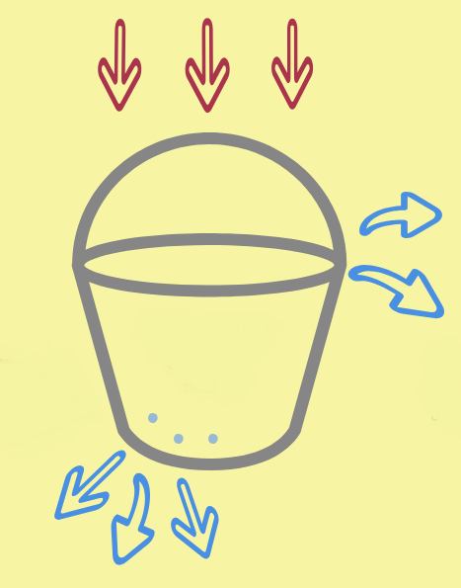

(4) What is blocking your holes? (consider the unhelpful things you do or what isn’t working for you anymore)

(3) What do you do to de-stress? (these are the holes in your bucket)

(2) How high is the water in your bucket right now? Do you notice this changing over time?

(1) What are your current stressors? (the water going in to your bucket)