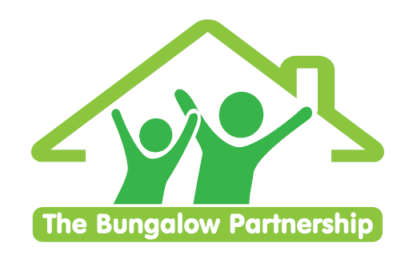

TRAINING EVENT
Wednesday 8th June 2022

**Limited Places— Book now to avoid disappointment **
NON-PROFIT ORGANISATION

Making and Using Masks
for Children and Young People in Therapy

Led by Cathie Sprague — Dramatherapist
Wednesday 8th June 2022 1-3pm

Venue: Barnardo’s Bridgeway Project, Tees Valley Services, Allendale Rd, Ormesby, Middlesbrough TS7 9LF

This is an experiential workshop for teachers and therapists which will explore….

- What is a mask? Why use masks with children/young people?
- Making a mask - participants will have a choice between 3 different types of masks to make and take away with you.
- Techniques for using masks.
- What can using masks tell us about children?

£52.00 per delegate
Includes taking home masks you make in the session

To book a place please contact
trainingthebungalowpartnership@gmail.com

This training is in high demand and places are limited so book early to avoid disappointment.

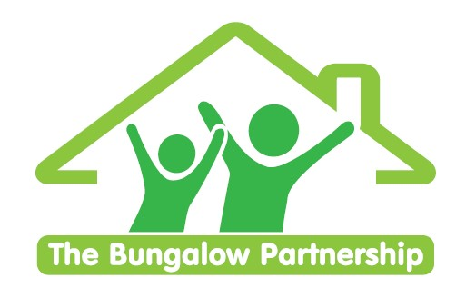 | TRAINING EVENTS  BOOKING FORM
CONTACT DETAILS
School/Organisation:_________________________________________________________________
Address: ________________________________________________________________________
________________________________________________________________________
Telephone: _____________________________ Email: ___________________________________
Contact: _______________________________Position in School: __________________________
Authorised by: __________________________Signature: __________________________________
TRAINING EVENT £52.00 per delegate

Making and Using Masks for Children and Young People in Therapy | - Wednesday 8th June 2022

DELEGATES

Name Email:
- _________________________________ ____________________________________________
- _________________________________ ____________________________________________
- _________________________________ ____________________________________________

TOTAL COST £ ______________
Please return completed booking form and accompanying Purchase Order (if required) to:
The Bungalow Partnership  Rose Wood Academy  The Garth  Coulby Newham  Middlesbrough  TS8 0UG  Tel: 01642 595363  Email: trainingthebungalowpartnership@gmail.com | 