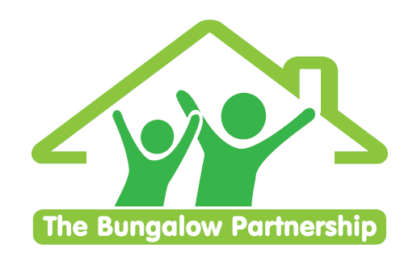

TWILIGHT TRAINING EVENT
Tuesday 17th May 2022

**Limited Places— Book now to avoid disappointment **
NON-PROFIT ORGANISATION

Supporting Children and Young People through bereavement

Led by Sarah Atkinson — Deputy Director/Children’s Counsellor
Tuesday 17th May 2022 3:45-6pm

Venue: Barnardo’s Bridgeway Project, Tees Valley Services, Allendale Rd, Ormesby, Middlesbrough TS7 9LF
This training is suitable for school staff, health professionals, social workers and youth workers. Within this workshop, you will…

- Gain awareness of the impact of bereavement and loss on children and young people.
- Recognise the changes in a young person’s behaviour that may indicate distress.
- Develop the skills, knowledge, understanding and confidence to support children and young people experiencing loss within your setting.
- Increase your confidence in identifying and responding to the emotional regulation needs of children and young people with these experiences.
- Learn a range of strategies and techniques to support children and young people experiencing grief.
- Feel more confident in supporting fellow staff and parents through periods of grief
- Explore together how settings and individuals can prepare for bereavement by developing policies, protocols and whole school/setting good practice.

£50.00 per delegate

To book a place please contact
trainingthebungalowpartnership@gmail.com

This training is in high demand and places are limited so book early to avoid disappointment.
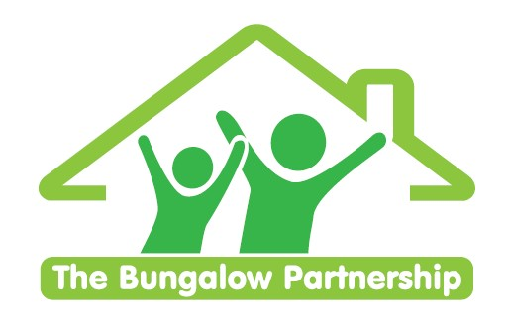 | TRAINING EVENTS  BOOKING FORM
CONTACT DETAILS
School/Organisation:_________________________________________________________________
Address: ________________________________________________________________________
________________________________________________________________________
Telephone: _____________________________ Email: ___________________________________
Contact: _______________________________Position in School: __________________________
Authorised by: __________________________Signature: __________________________________
TRAINING EVENT £50.00 per delegate

Supporting Children and Young People through Bereavement | - Tuesday 17th May 2022

DELEGATES

Name Email:
- _________________________________ ____________________________________________
- _________________________________ ____________________________________________
- _________________________________ ____________________________________________

TOTAL COST £ ______________

Please return completed booking form and accompanying Purchase Order (if required) to:
The Bungalow Partnership
Rose Wood Academy
The Garth
Coulby Newham
Middlesbrough
TS8 0UG
Tel: 01642 595363
Email: trainingthebungalowpartnership@gmail.com

