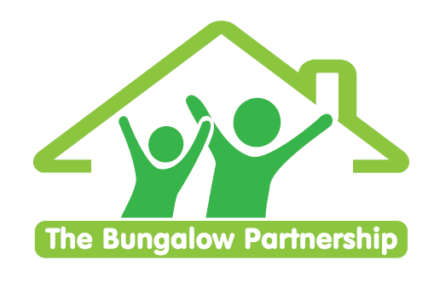

TRAINING EVENT
Monday 16th May 2022

**Limited Places— Book now to avoid disappointment **
NON-PROFIT ORGANISATION

Supporting the Needs of Children and Young People who are in Local Authority or
Kinship Care

Led by Marie Blythe —Director/Play & Filial Therapist
Monday 16th May 2022 1-4pm

Venue: Barnardo’s Bridgeway Project, Tees Valley Services, Allendale Rd, Ormesby, Middlesbrough TS7 9LF
Children and Young People who have experienced early life disruption may require additional support to ensure they achieve their potential. To plan and prepare for the support needed, those supporting the child/young person at home, school and in the community need to understand how such early experiences may impact the child/young person. The Bungalow Partnership recognises the developmental trauma many of our children/young people have experienced. We recognise also that these experiences and impacts do not belong alone to children within the care of the Local Authority and that many children residing in Kinship Care require the same levels of support to recover from their experiences. This training aims to develop the awareness of participants of the impacts of such developmental trauma and good practice in responding to these children and young people

Within this workshop, you will …

- Explore a child or young person’s journey into Local Authority or Kinship Care.
- Examine the impacts of early life disruption and the resulting psychological, regulatory and developmental consequences of such trauma and relational severance.
- Acknowledge the challenge of responding to and repairing early life disruption in children and young people, including placements, family contact, education and therapy.
- Consider what we can each do to support children/young people within Local Authority and Kinship Care.

£60.00 per delegate

To book a place please contact
trainingthebungalowpartnership@gmail.com
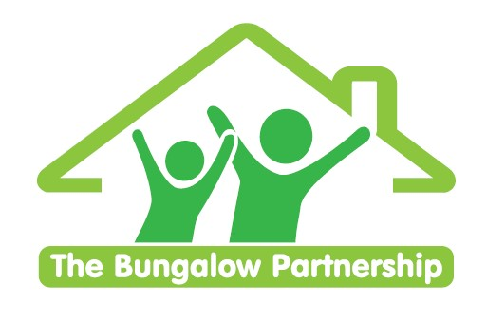 | TRAINING EVENTS  BOOKING FORM
CONTACT DETAILS
School/Organisation:_________________________________________________________________
Address: ________________________________________________________________________
________________________________________________________________________
Telephone: _____________________________ Email: ___________________________________
Contact: _______________________________Position in School: __________________________
Authorised by: __________________________Signature: __________________________________
TRAINING EVENT £60.00 per delegate

Supporting the Needs of Children and Young People who are in Local Authority or Kinship Care | - Monday 16th May 2022

DELEGATES

Name Email:
- _________________________________ ____________________________________________
- _________________________________ ____________________________________________
- _________________________________ ____________________________________________

TOTAL COST £ ______________

Please return completed booking form and accompanying Purchase Order (if required) to:
The Bungalow Partnership  Rose Wood Academy  The Garth  Coulby Newham  Middlesbrough  TS8 0UG  Tel: 01642 595363  Email: trainingthebungalowpartnership@gmail.com | 